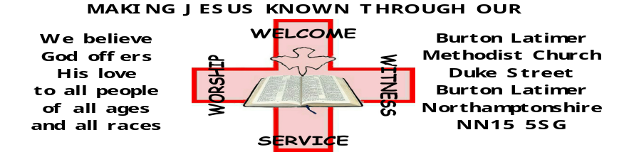

WELCOME TO MORNING WORSHIP - Refreshments are served after the Service

The Anglican, Baptist, Roman Catholic and Methodist churches, invite you to pray for, and speak God's Blessing over, the people who live and/or work in Burton Latimer. The street for prayer this week is COPSE CLOSE.

NOTICES FOR THIS WEEK BEGINNING 3RD SEPTEMBER 2017

- Sometimes we are thirsty for prayer but not sure how to pray, or are looking for a new way to go about it. “Come to the Well” is a six session course offering suggestions and opportunities for exploring different pathways. The aim of the course is to help people to pray and live more reflectively, thereby entering a deeper relationship with God. The invitation is to “Come to the Well”, drink and be refreshed, restored and resourced. When is it? Wednesday evenings 13th, 20th and 27th September and the 4th, 11th and 18th October. Where is it? Cornerstone Methodist Church, Corby What time is it? 7:00-9:00pm (meet at 6:45). It is important that we know who will be attending so that we can prepare material for each person. Paula King.

- Please note that there is NO SERVICE here in the morning next week. Instead we are invited to a Circuit Covenant service at Rothwell at 10.30am. Transport can be arranged – please ask a steward.

Notices for next Sunday to Andrew by Wednesday please.

To use the INDUCTION LOOP SYSTEM please switch your HEARING AID to the 'T' position. You may need to adjust your volume level.
Our Web Site : www.blmchurch.co.uk

Our Email : contact@blmchurch.co.uk

www.facebook.com/BurtonLatimerMethodistChurch
KETTERING/CORBY CIRCUIT Web Site : www.ketteringcorbymethodists.org.uk

WELCOME TO MORNING WORSHIP - Refreshments are served after the Service

The Anglican, Baptist, Roman Catholic and Methodist churches, invite you to pray for, and speak God's Blessing over, the people who live and/or work in Burton Latimer. The street for prayer this week is COPSE CLOSE.

NOTICES FOR THIS WEEK BEGINNING 3RD SEPTEMBER 2017

- Sometimes we are thirsty for prayer but not sure how to pray, or are looking for a new way to go about it. “Come to the Well” is a six session course offering suggestions and opportunities for exploring different pathways. The aim of the course is to help people to pray and live more reflectively, thereby entering a deeper relationship with God. The invitation is to “Come to the Well”, drink and be refreshed, restored and resourced. When is it? Wednesday evenings 13th, 20th and 27th September and the 4th, 11th and 18th October. Where is it? Cornerstone Methodist Church, Corby What time is it? 7:00-9:00pm (meet at 6:45). It is important that we know who will be attending so that we can prepare material for each person. Paula King.

- Please note that there is NO SERVICE here in the morning next week. Instead we are invited to a Circuit Covenant service at Rothwell at 10.30am. Transport can be arranged – please ask a steward.

Notices for next Sunday to Andrew by Wednesday please.

To use the INDUCTION LOOP SYSTEM please switch your HEARING AID to the 'T' position. You may need to adjust your volume level.

Our Web Site : www.blmchurch.co.uk

Our Email : contact@blmchurch.co.uk

www.facebook.com/BurtonLatimerMethodistChurch
KETTERING/CORBY CIRCUIT Web Site : www.ketteringcorbymethodists.org.uk

